**CASE 1:** Reference of Parent holding Child. There is Polymorphism.

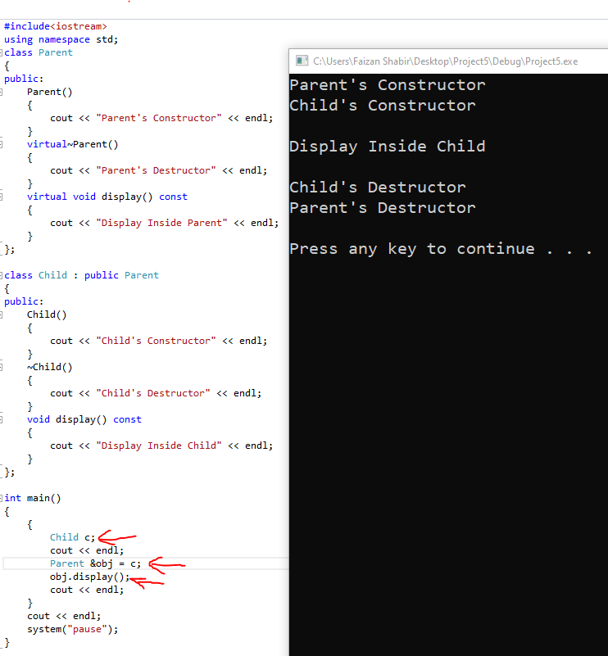

**CASE 2:** Pointer of Parent holding Child’s Address. There is Polymorphism.

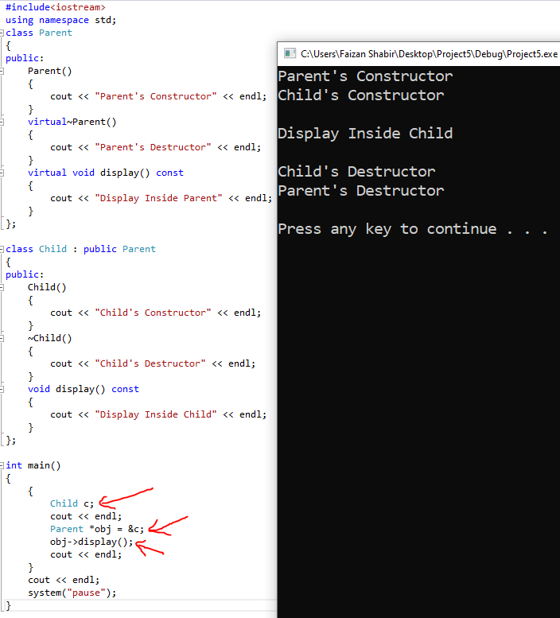

**CASE 3:** Object of Parent holding Object of Child. There is NO Polymorphism.

